1. Download GitHib for Windows

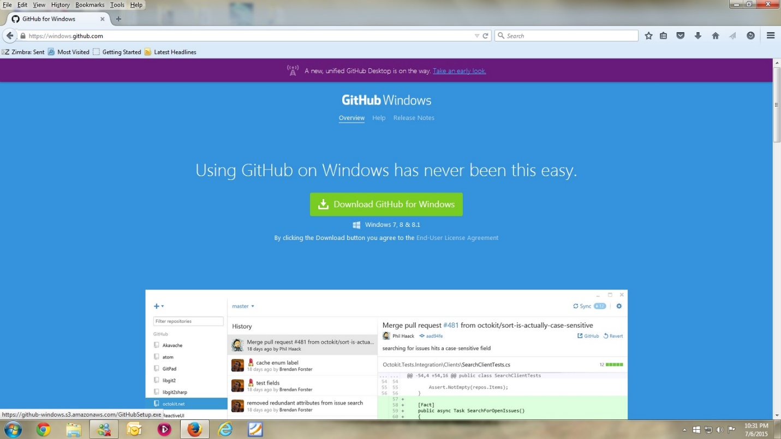

1. Save File

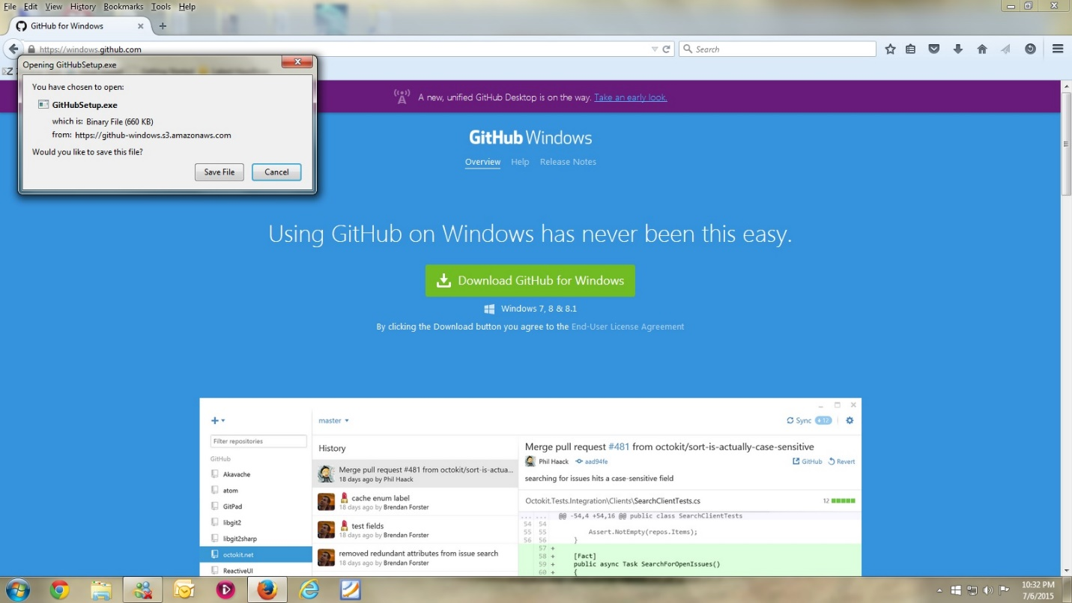

1. Double Click

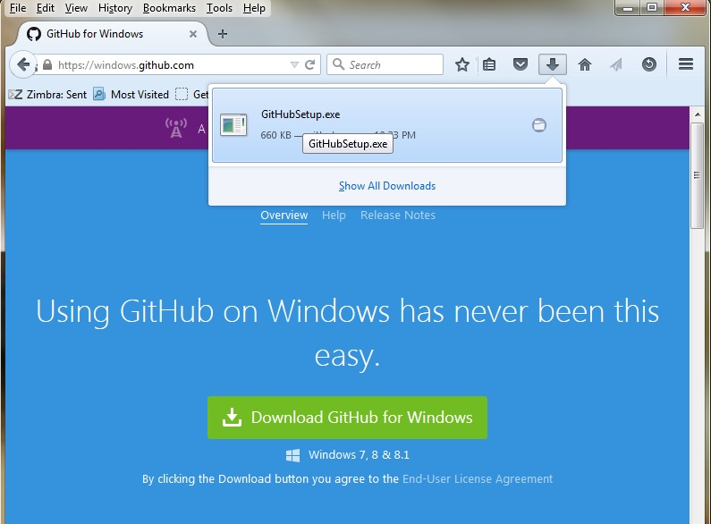

1. Run

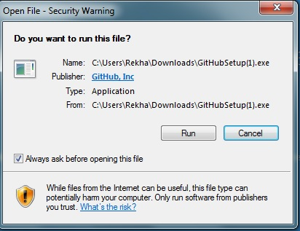

1. Click Install

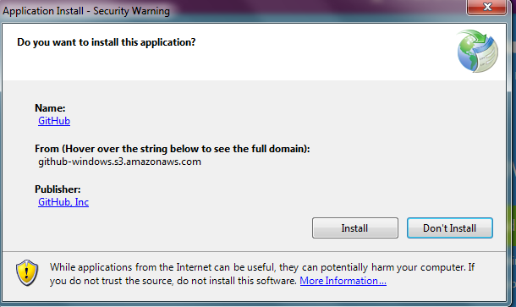

1. Installation Starts

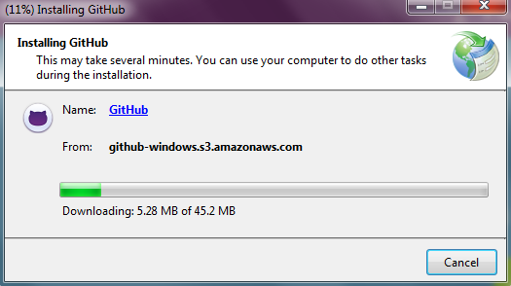

1. Notice these icons on your Desktop

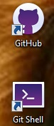

1. GitHub for Windows opens up

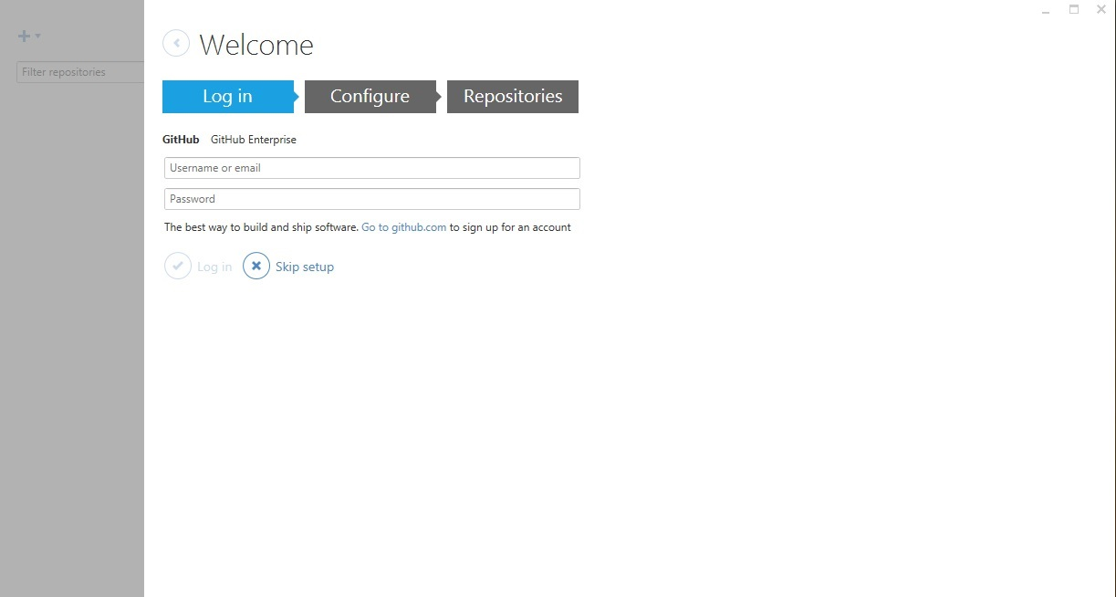

1. Notice these icons on your Desktop

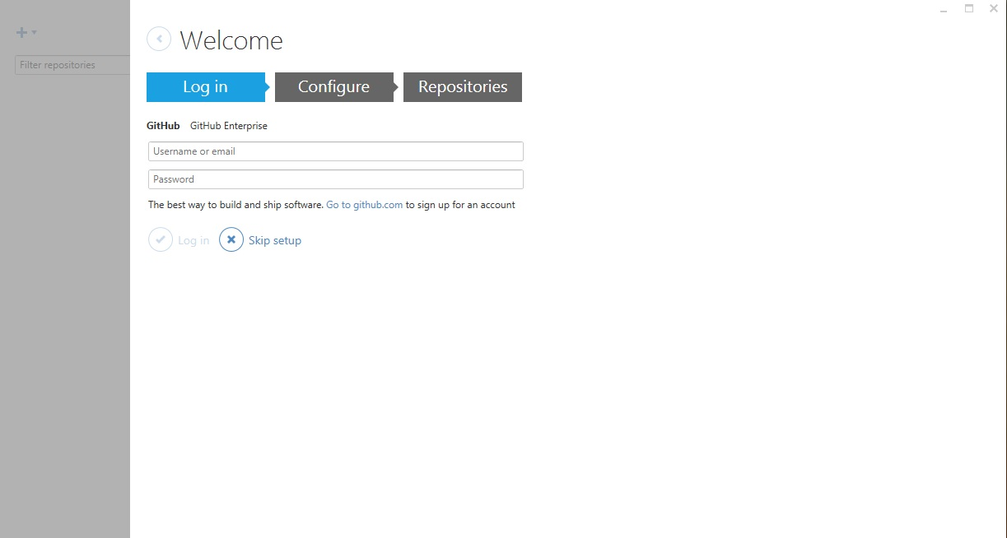

1. Login with your GitHub email address(FAU) and PW

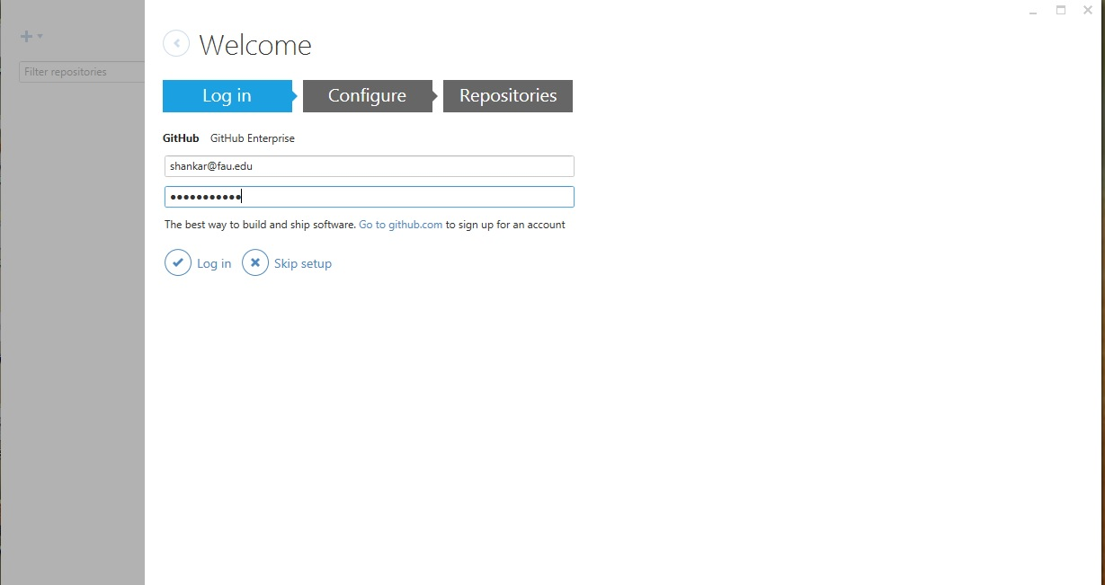

1. Click continue

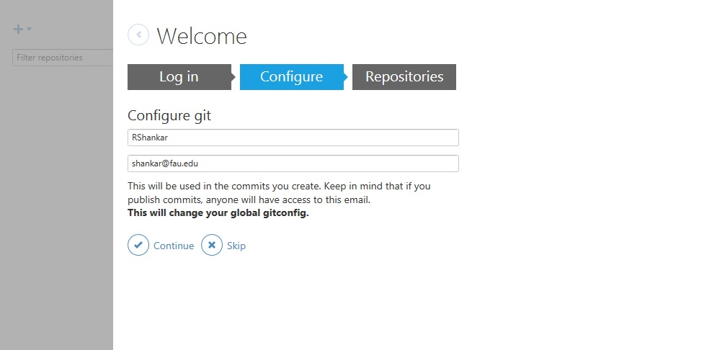

1. Click on dashboard

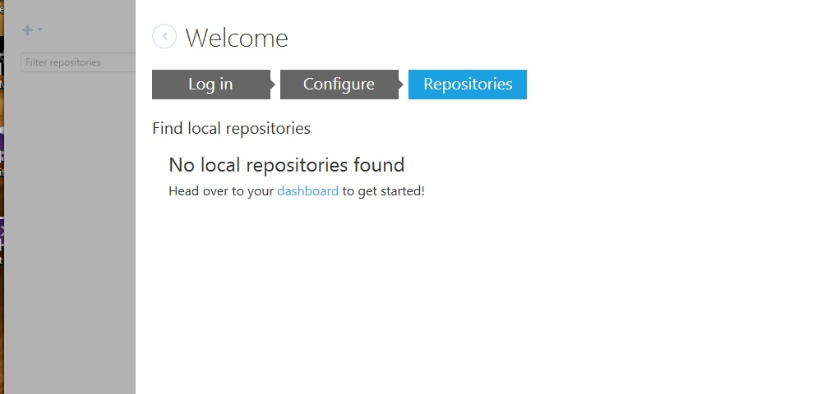

1. See this screen

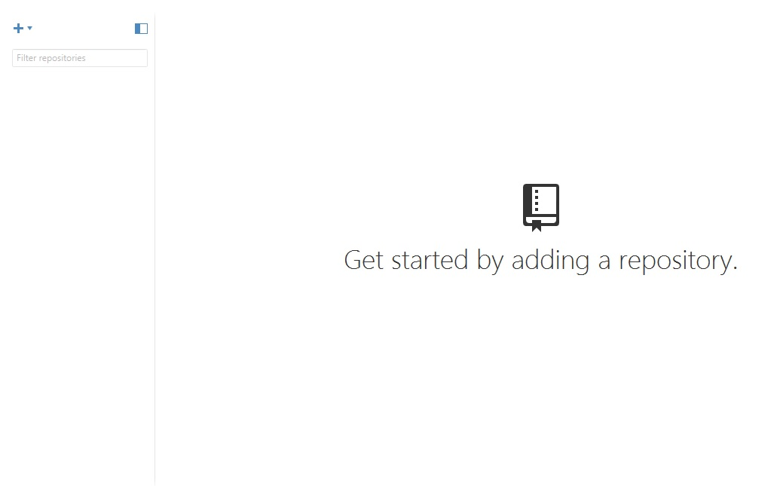

1. Go to MODSApps – Information at GitHub

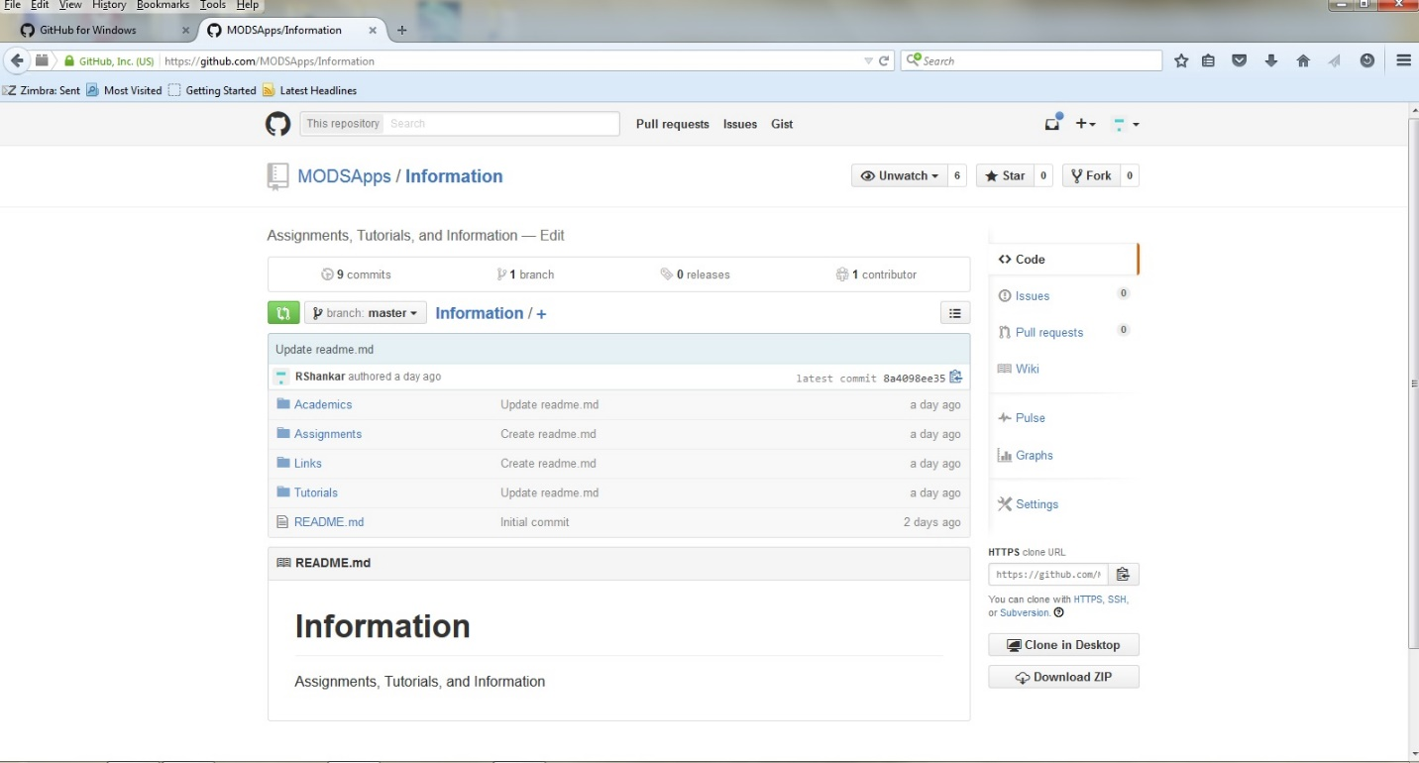

1. I clicked on Clone – you will click on Fork – check on Remember and OK.

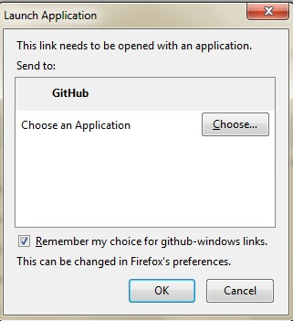

1. Notice the GitHub folder under MyDocuments. Click OK

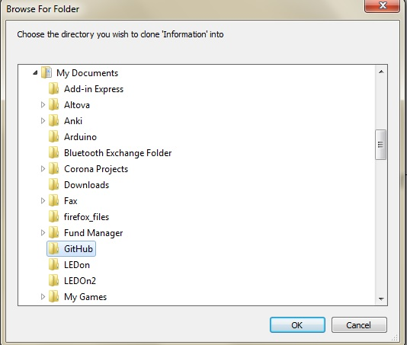

1. Go to the folder

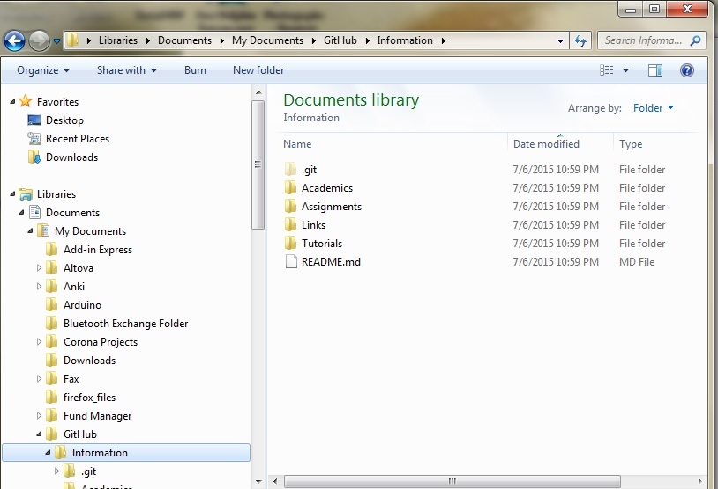

1. Notice only readme.md in your folder

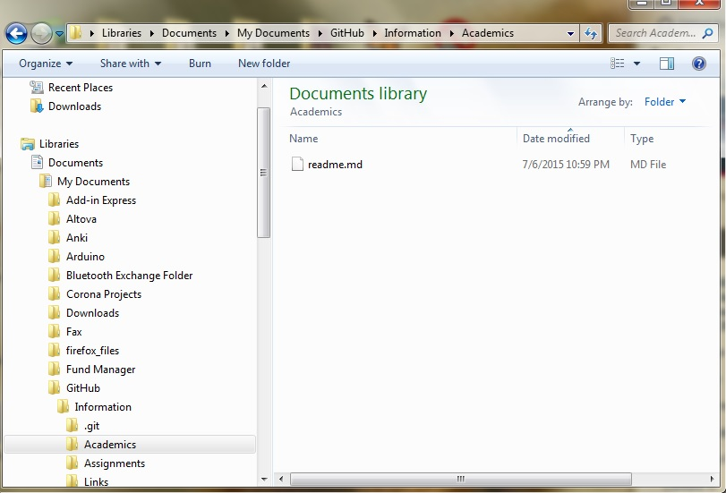

1. Add folders that you wish to commit. You can revise them here itself. Commits will track revisions

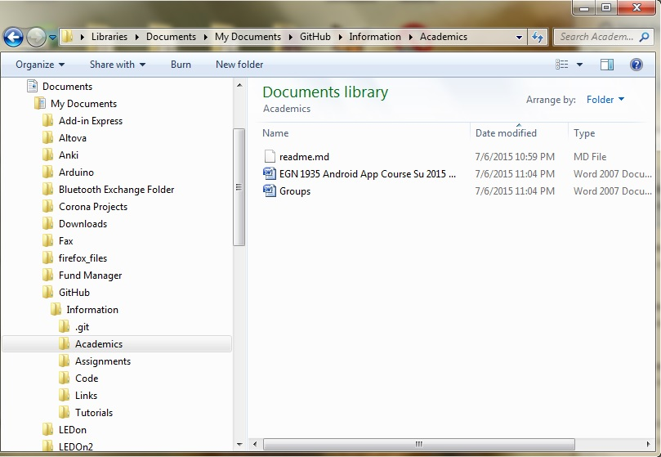

1. Open GitHub for Windows – notice all uncommitted changes appear automatically here

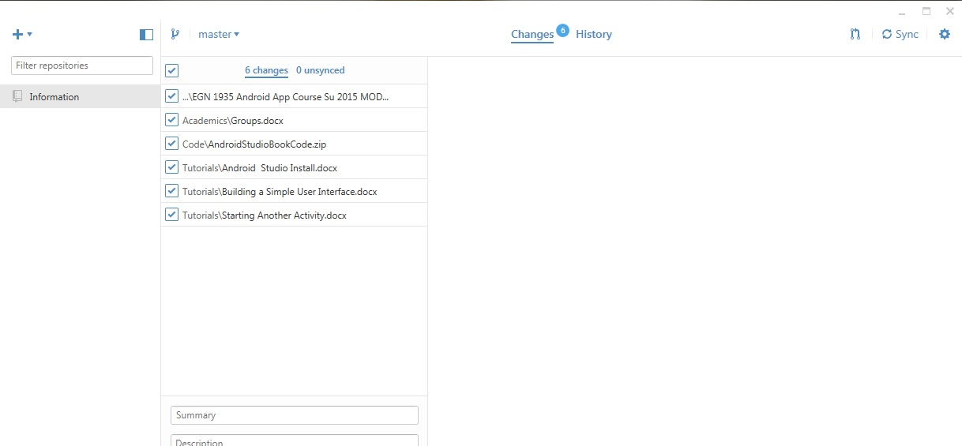

1. Fill out the summary and Details windows with relevant info and click ‘Commit to Master’

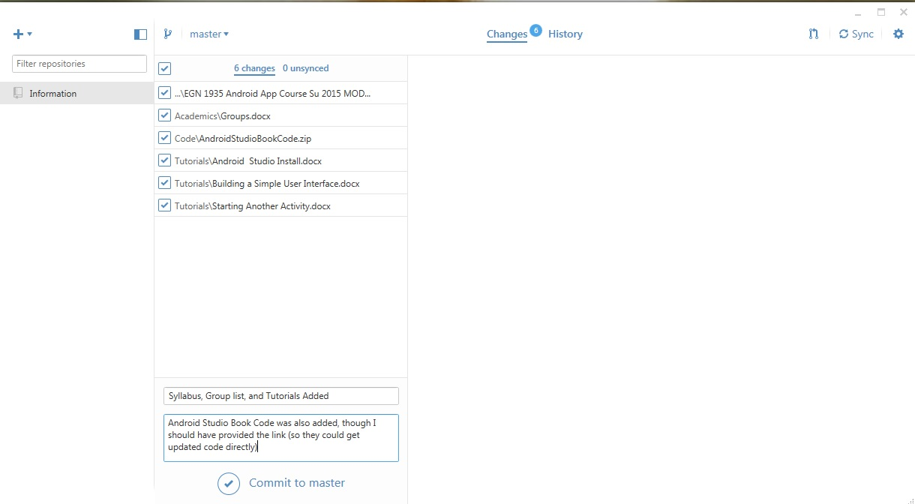

1. Notice the commit to GitHub site is ready – see the blue banner at the bottom. Click the Sync at the right top to upload to the GitHub site

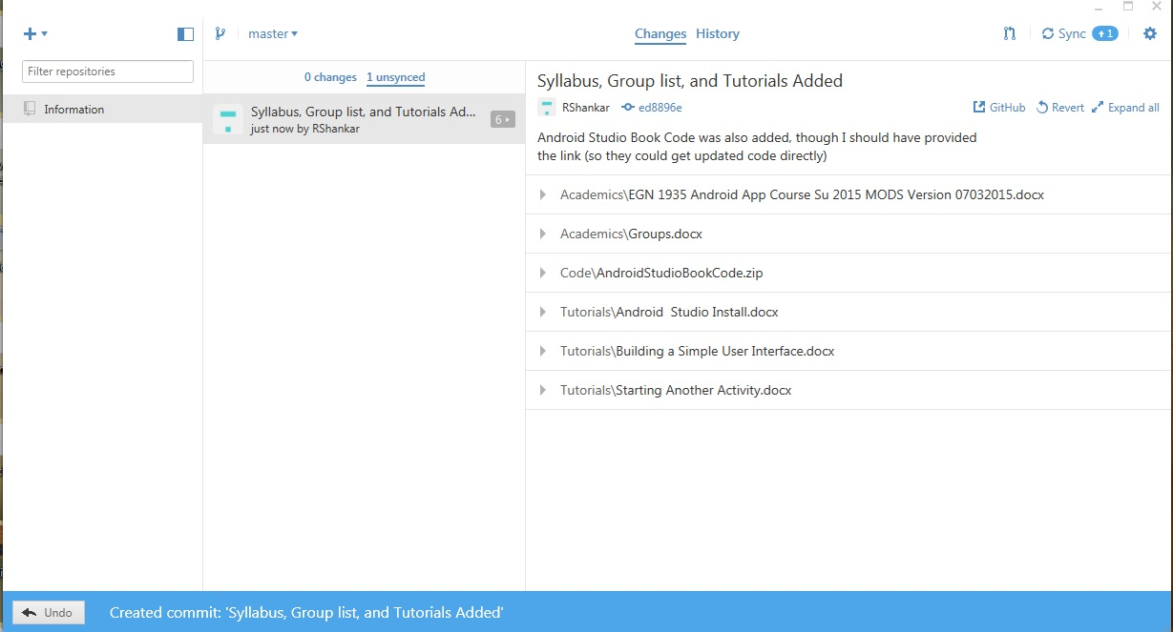

1. After a while it shows that it says synced

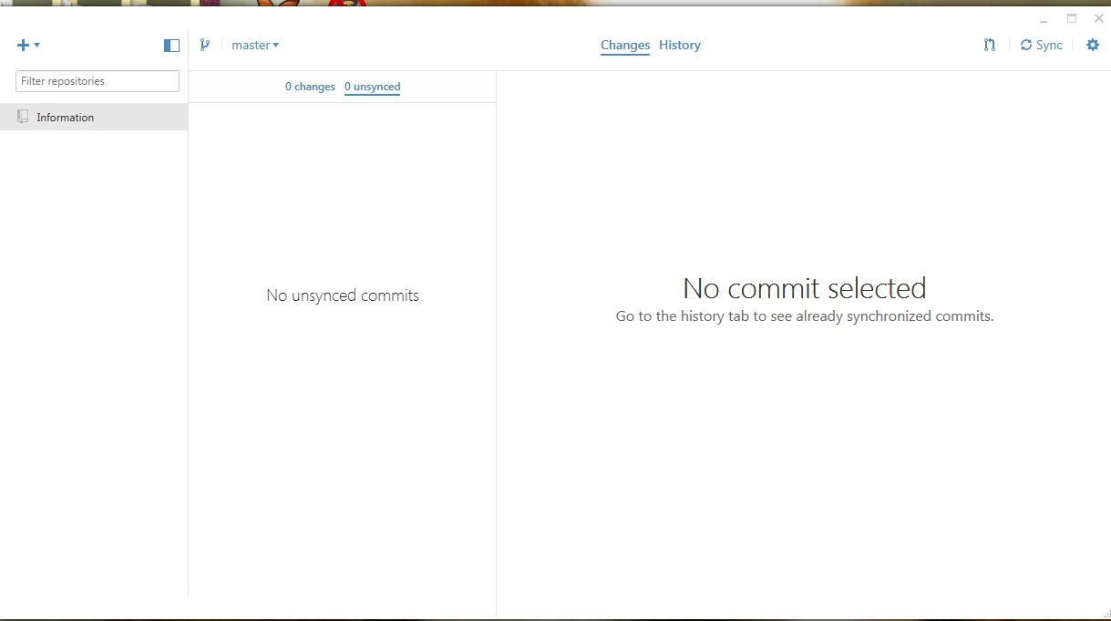

1. Verify that the GitHub site has the update

